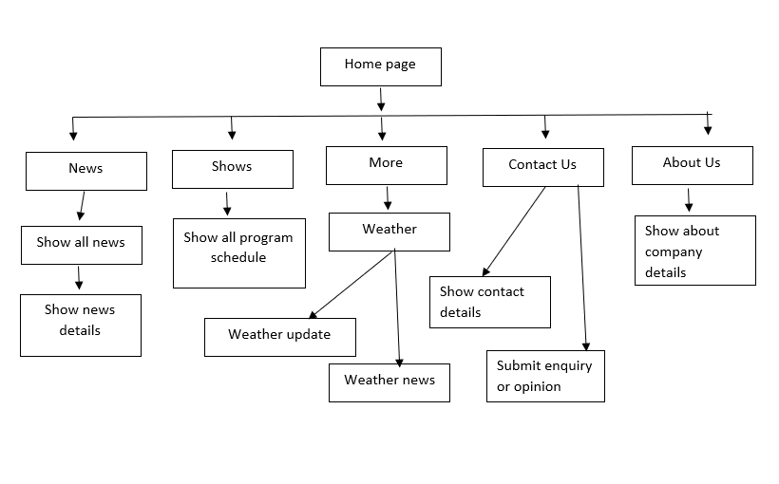

Figure 1 Site Information Architecture